Instructions:
Read carefully this pre-review article template before you write an article for Automotive Experiences. Pre-review article templates consist of a Title page and full-text article. Article should be written by Palatino Linotype with font 11 and spaces 1.5.

Table of content
1. Introduction 2
2. Method 3
3. Result and Discussion 4
3.1. Presenting the Results 4
3.2. Create a Discussion 4
4. Conclusion 6
5. Acknowledgement 6
6. References 6
Presenting Figures and Tables 7
Equation 8
Unit 9
Additional Information 9

After you read and understand this template, delete this first page!.

Write Title Here: Title Must Be Simple, Informative, and Reflect Important Findings of the Article

Your Full Name^{1*}, Your Full Name ², Your Full Name ³
¹Name of Department, University, Postal Code, Country
²Name of Department, University, Postal Code, Country
³Name of Department, University, Postal Code, Country

Email: correspondingauthor@blablabla.con

Abstract
The abstract must be short, interesting, simple, and easy to understand without reading the entire article. Therefore, avoid jargon, abbreviations and references. In writing abstracts, the author must be accurate, use the right words, and convey the meaning of the study. A good abstract contains the problem statement and purpose, how the research is carried out (the method), the results, and concludes with a brief statement of conclusions. In the abstract keywords are also always included. Keywords are used to index an article and are the label of an article.
Keywords: Write 3-6 keywords separated by semicolon

Write Title Here: Title Must Be Simple, Informative, and Reflect Important Findings of the Article

Introduction
The introduction is an opportunity for the author to convince the reader (including editors and reviewers) that the author mastering the research carried out has significance or contributes to the field of study. The introduction contains "What do you / others do? Why did you do it? "
A good introduction must answer the following questions:
- What is the problem that must be solved (problem statement) ?
- What people have done to solve existing problems, from time to time (state of the arts) ?
- What escaped the attention of previous researchers or what the potential is available and not yet explored by other researchers ?
- What concepts are offered to fill the "blanks" or something that has escaped the attention of previous researchers ?
- What is to be achieved from this work ?
When the author submits the manuscript, the editor wants to see that the author has provided a perspective that is consistent with aim and scope this journal. The author needs to explain the concepts offered and the novelty of the research based on quotations from several original and important works from several journals, including the most recent review articles. A review article is very important to read because it provides an overview of the development of the field up to the last article. The author can search deeper by looking for the original paper contained in the bibliography of a review article.
The introduction should be concise but meaningful. Although the introduction requires an explanation of "state of the art" until the article is written, do not draw far back. A long and excessive introduction will make the reader stop reading. An introduction can be presented in the following structure.
The first paragraph, write down the issues of concern to researchers today. Problems must be objective, not from an author's perspective. Do not let something "considered a problem" by the author, but actually not a problem for the field of study.
In the following paragraphs, what people have done to solve the existing problem (state of the art). In this context, the author also needs to limit the problem to stay focused. How the methods and results reported by previous researchers need to be written in this section. After the state of the art is awakened, focus on "what has escaped the attention of previous researchers?", Giving wise scientific criticism of the advantages and disadvantages of the methods or results of previous studies. Furthermore, what concepts are offered in order to contribute to solving the problems that have been written before. This is what is called "novelty". However, there is no need to state in the sentence that this concept is "novel", "first time", "first", "paradigm change", and so on. The disclosure of state of the art that is given scientific criticism so that the author is able to find a new differentiator, is enough to give the impression to the reader that it is indeed "new". Next, describe how the concepts / ideas / ideas offered have convincing scientific value.
The final paragraph, what you want to achieve from this work (objectives) and give an introduction to the method.

Method
The method section is written based on the question "how was the problem solved". If a manuscript proposes a new method, all information about the new method must be presented in detail so that the reader can reproduce the experiment (example in Figure 1). However, the author does not need to repeat the details of an established method, just use references and supporting material to show the established procedure.
It is important to note that methods must be written in the same order in the results section. The order of writing methods must also be logical according to the type of research. The method for one type of research will be very different from other studies. For example, writing survey research methods is very different from laboratory test research methods that involve a lot of equipment and materials. The method section can be created with several separate subtitles such as materials, tools, and data collection procedures.
Very likely, a novelty from a study is in the method section, even though the topic is the same as previous studies. New methods that are simpler but have the same ability to answer research questions are superior so that they can be replicated or applied by subsequent researchers. In addition, if the equipment has accuracy tolerance in reading data such as thermocouple, transducer, air flow meter, etc., it must also be stated clearly and honestly in the method section.

Result and Discussion
Results and discussion can be made as a whole that contains research findings and explanations.

Presenting the Results
This section contains answers to the questions "what have you found". Therefore, only representative results from the research are presented. What is meant by "representative results" are results that represent the research findings, which lead to the discussion. Generally, research results are presented in figures or tables, but can also be in the form of descriptions for certain cases.
Although, good figures and tables are interesting and easy to understand, but the most important thing is that the results / data presented in the figure or table are honest. If an image can only be understood with the support of research data which may require half or a full page of paper, then the data should be included as an appendix. Do not hide important data that raises reader questions or leads to mistrust of the reader. If this happens, the noble goal of publication as "academic charity" will not be achieved.
The results section is written following the chronological order as presented in the method section. The important thing in presenting results is that the author must not include references in this section. This section is the "findings" of the author himself. However, if the results of the study are presented in a figure or table that directly compares with the findings of another person, the part of the figure or table must include the findings of that other person, without the need to discuss it in this section.

Create a Discussion
In this section, the author must respond "what is meant by the results obtained and claimed as research findings". This section is the part that seems easy to write, but is the hardest part to get it right and this is the most important part of an article. Most of the manuscripts received serious attention from editors and reviewers because the discussion was weak, and many were even returned for re-submission or rejected.
In this part of the discussion, the author needs to make a "discussion" in accordance with the results of the research presented, but do not repeat the results. The author needs to compare the results of the study with the results of previous studies (some of which are contained in the introduction). Maybe, a research result clarifies the results of previous studies, improve, or even contradict. Whatever the outcome, the author must make a "dialogue" with the results of other researchers, based on the existing grand theory. If the findings turn out to be different from other people's findings, this may be extraordinary, and in turn, the author must face it and convince the reader that this finding is true or better than the previous one. Although this truth also sometimes does not last for a long period of time, because it will be perfected with new truths reported by other researchers. That's how science works.
Some tips for making a discussion on a manuscript:
- Avoid statements that go beyond the results of the study, if valid data support is not available.
- Avoid nonspecific expressions such as "temperature too high", quantitative descriptions are much better (write 105 ° C to express the measured temperature).
- Avoid sudden recognition of terms, including new abbreviations that are not standardized; The author must present everything in the introduction, before all of that is present suddenly in the discussion.
- Speculation about possible interpretations is permissible, however, it must be rooted in reality, not imagination. To achieve good interpretation, several things need to be considered:
  - How do the results of this study relate to the research question or initial objectives outlined in the introduction.
  - Does the data obtained support the hypothesis that was created when making a research proposal.
  - Are the results of this study in accordance with what has been reported by other researchers.
  - If the results of this study are unexpected, the author needs to provide and explain the reasons, including what are the strengths and weaknesses.
  - Are there other ways that are newer and easier for readers to interpret the results of this study.
  - What further research is needed to answer questions that cannot be revealed from this research.
  - Explain what is new from this finding, without exaggerating.

Conclusion
The conclusion section contains a summary of the research findings, which correlate with the research objectives written in the introduction. Then state the main points of the discussion. A conclusion generally concludes with a statement about how the research work contributes to the field of study as a whole (shows how progress from the latest knowledge). A common mistake in this section is to repeat the results of an experiment, abstract, or be presented with a very list. The concluding section must provide clear scientific truths. In addition, the conclusions can also provide suggestions for future experiments.

Author's declaration
Authors’ contributions and responsibilities
Write the contribution of each author here, or mark the following column.

The authors made substantial contributions to the conception and design of the study.
The authors took responsibility for data analysis, interpretation and discussion of results.
The authors read and approved the final manuscript.

Funding
Write down the research funding, if any.

Availability of data and materials
√ | All data are available from the authors.

Competing interests
√ | The authors declare no competing interest.

Additional information
Write additional information related to this research, if any.

Acknowledgement
In the acknowledgment section, the author can state the source of research funding and more specifically to the contract number. Make sure the statement complies with the guidelines provided by the funding agency. The author can also express his thanks to reviewers and proofreaders, or technicians who help prepare equipment set-ups or students who assist in surveys.

References
Usually, there are more errors in references than other parts of the manuscript. However, with reference management software, it is now easier to avoid this problem. In the text, the author must quote all references referred to and vice versa. Minimize the use of personal communication, do not include unpublished observations, manuscripts that have not been received for publication, publications that are not reviewed by reviewers, or gray literature. Prioritize articles in English and articles from reputable journals.
To make accountable references, the author can use reference management software, such as EndNote or Mendeley. Make a list of references and citations in text that fit the IEEE style. Example of writing references in IEEE style:
[1] L. Augusto Horta Nogueira and R. Silva Capaz, “Biofuels in Brazil: Evolution, achievements and perspectives on food security,” Global Food Security, vol. 2, no. 2, pp. 117–125, 2013.
[2] A. Pradhan and C. Mbohwa, “Development of biofuels in South Africa: Challenges and opportunities,” Renewable and Sustainable Energy Reviews, vol. 39, no. 2014, pp. 1089–1100, 2014.
[3] M. Messagie, K. Lebeau, T. Coosemans, C. Macharis, and J. Van Mierlo, “Environmental and financial evaluation of passenger vehicle technologies in Belgium,” Sustainability, vol. 5, no. 12, pp. 5020–5033, 2013.

Presenting Figures and Tables
Before writing the manuscript, the first step that must be taken is to prepare Figures and Tables that are processed from the results of the study (if any). Keep in mind that a Figure and Table are worth a thousand words. Therefore, figures and tables are the most efficient way to present the results of research. Figures and tables must be presented with high quality / sharpness. The use of graphics / curve fitting software and its analysis such as Origin Graphing and Analysis (can be obtained at http://www.originlab.com/) is highly recommended for making graphics that can be displayed with good quality and clear.
Generally, tables provide actual experimental results, while figures are often used for comparison of experimental results with previous work, or with calculation / theoretical values.
- When presenting figures and tables, several things need to be considered:
- Avoid graphic plots that are too crowded.
- Use the appropriate axis.
- Symbols and data sets must be clear, easily distinguishable.
- If the table contains very much data, put the table as an attachment, not as body text.
All images should be made in high quality JPEG format, at least 300 dpi with sharp color settings. A good illustration to present the results of the study is presented in Figure 1.
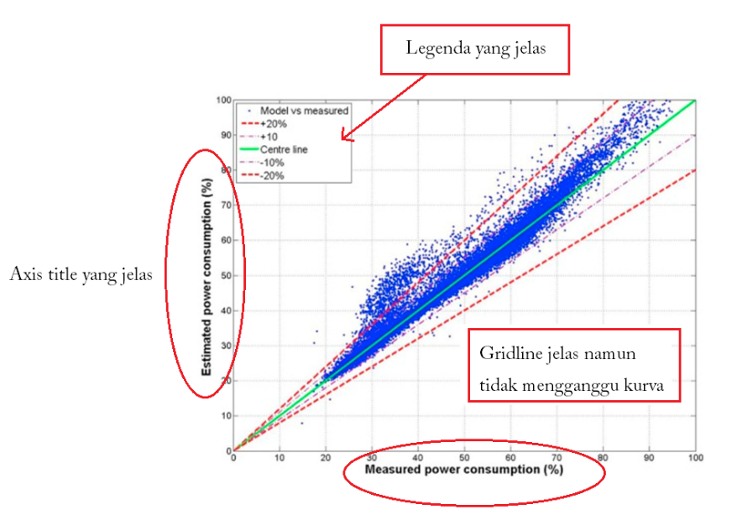
Figure 1. Example of a research result shown in the figure [4].

A good figure, always equipped with a legend and without giving the title of the image at the top. The coordinate axis is clearly visible with a scale that can be read easily. The colors on the grid line are made dimmer than the plot. Then, an example showing a table of good research results is presented in Table 1 as follows.
Table 1. Example shows research data in Table [5]
Materials | Variables | Temperature (°C)
 |  | 250 | 300 | 350
Scrap tyre | Stove temperature (°C) | 401 | 492 | 525
 | Water temperature (°C) | 25 | 25 | 25
 | Condenser temperature (°C) | 26 | 26 | 26
 | Oultet condenser temperature (°C) | 26 | 27 | 27
 | Outlet Reactor (°C) | 29 | 36 | 53
 | Liquid volume (ml) | 160 | 175 | 190
 | Liquid temperature (°C ) | 25 | 26 | 25
Scrap tyre and catalyst | Stove temperature (°C) | 398 | 490 | 528
 | Water temperature (°C) | 25 | 25 | 25
 | Condenser temperature (°C) | 26 | 26 | 26
 | Oultet condenser temperature (°C) | 25 | 27 | 38
 | Outlet Reactor (°C) | 29 | 30 | 50
 | Liquid volume (ml) | 150 | 160 | 165
 | Liquid temperature (°C ) | 28 | 30 | 30

Equation
The mathematical equation must use the "Equation Editor" and be given the serial number in (1) (2), (3) and so on.

Unit
The unit must use the International Unit.

Additional Information
- All figures, tables and equations must be mentioned in the paragraph before the figures, tables and equations are displayed. Avoid the words "Next figure, Table above, Equation below", replace it with the clear statement of Figure 1, Table 3, Equation (4), and so on.
- Use Indonesian or English properly and correctly.

