**English Article Title** (Concise, Clear, and Informative Title Maximum 15 Words: Book Antiqua Font Size 14, Bold, Sentence case, Single Spacing, Align text left)

|  |  |  |
| --- | --- | --- |
| No | Author’s Full Name (Do not abbreviate, without titles) | Email |
| 1 | Author’s Full Name 1 | Author’s Email 1 |
| 2 | Author’s Full Name 2 | Author’s Email 2 |
| 3 | Author’s Full Name 3 | Author’s Email 3 |
| … | … | … |

1,2 Affiliation 1,2 etc. (If the institution is the same)

3 Affiliation 3, (if the institution is different)

Corresponding Author Email: [authors@gmail.com](mailto:authors@gmail.com)

WhatsApp: +62……. (WhatsApp of corresponding author) (if any)

|  |
| --- |
| **Abstract** |
| *The abstract, written in English, should be between 100-250 words and presented in a single paragraph. The abstract should be clear, concise, and descriptive. This abstract should provide (a) a brief introduction to the problem, (b) objective of the paper, (c) the methodology, (d) a brief summary of results, (e) conclusion, and (f) recommendation (if any) (Book Antiqua 10.5pt - single line spacing - 6pt after paragraph).* |
| **Keywords**: *3 – 5 words that represent the article and separated by semicolons (;).* |

**Indonesian Article Title** (Concise, Clear, and Informative Title Maximum 15 Words: Book Antiqua Font Size 14, Bold, Sentence case, Single Spacing, Align text left)

|  |
| --- |
| **Abstrak** |
| The abstract, written in Indonesian, should be between 100-250 words and presented in a single paragraph. The abstract should be clear, concise, and descriptive. This abstract should provide (a) a brief introduction to the problem, (b) objective of the paper, (c) the methodology, (d) a brief summary of results, (e) conclusion, and (f) recommendation (if any). (Book Antiqua 10.5pt - single line spacing - 6pt after paragraph). |
| **Kata Kunci:** 3 – 5 words that represent the article and separated by semicolons (;). |

1. Introduction

The introduction to this article provides a holistic understanding of the discussed topic, presented clearly and succinctly. It encompasses: (a) an adequate background and significance of the paper; (b) concise previous studies relevant to the issue addressed in the manuscript; (c) the aspirations of this work to overcome these limitations or specific problem-solving ideas and proposed solutions that this community engagement activity will implement, (d) novel contributions of this paper; and (e) the specific aim(s) of the study.

Please note that all writings should be in paragraph format, as this journal discourages the use of numbered lists. The manuscript should be written using Book Antiqua 11pt - single line spacing - 6pt after paragraph. For the Articles section, the length should be 3,000-7,000 words (including references) with a minimum of 20 references (80% from journal articles). The Technical Note section should have a length of 2,000-5,000 words (including references).

1. Method

In writing the method section, the implementation method of community development is described descriptively, providing an overview of the approach used in the community development activities and the data collection methods for evaluation. The aim is to provide a clear understanding to the readers regarding the steps taken in the implementation of this community service to address problems through the dissemination of research results and expertise (Book Antiqua 11pt - single line spacing - 6pt after paragraph).

1. Results and Discussion

This section is the most important section of your article. The analysis or results of the research should be clear and concise. The results and discussion are presented with a detailed description of the program and the results obtained during the activities (impact of benefits). Explanations must be supported by activity photos or adequate data. The impact of the benefits should be presented in a measurable manner. Please highlight the differences between your findings and previous publications by other researchers. This section can also be divided into several sub-chapter (Book Antiqua 11pt - single line spacing - 6pt after paragraph).

* 1. **Sub-Chapter 1**

xxxxxxx

* 1. **Sub-Chapter 2**

xxxxxxx

1. Conclusion

The conclusion explains the impact of the research results and/or expertise dissemination program to address community problems. Provide a clear and concise conclusion. The conclusion should not repeat the results and discussion, but rather focus on the impact of the activities as expected in the objectives section. The conclusion should also present the implications of the program for the target community. This section may also include development suggestions or limitations (Book Antiqua 11pt - single line spacing - 6pt after paragraph).

Acknowledgements

Include acknowledgements to those who contributed to and supported the publication and program (Book Antiqua 11pt - single line spacing - 6pt after paragraph).

Author Contribution

State the contributions of the entire team of authors in the program and the article writing process (Book Antiqua 11pt - single line spacing - 6pt after paragraph). Only authors who have contributed can be included in the article and indicated by their names (Fitriana Yuliastuti; FY).

Example:

Activity implementation: AB, AA, AD; Article preparation: AA, AE; Analysis of service impact: AB, AD; Presentation of service results: AA; Article revision: AE. And other contributions.

Conflict of Interest

The authors state that there is no conflict of interest in the publication of this article.

Funding

The authors explain the funding sources for the program and publication.

References

For writing the references, the use of a reference management application like Mendeley is recommended. The citation and reference list formatting adheres to the **7th edition of the American Psychological Association (APA)** style. Only sources explicitly cited within the article text are included in the References section. A minimum of 20 references should be cited, with a strong emphasis on incorporating recent, reputable journal articles or proceedings.

Example:

Astini, N. K. S. (2020). Pemanfaatan Teknologi Informasi dalam Pembelajaran Tingkat SD di Masa Pandemi. *Jurnal Lampuhyang (Lembaga Penjaminan Mutu Stkip Agama Hindu Amlapura)*, *11*(2), 13–25.

Haqien, D., & Rahman, A. A. (2020). Pemanfaatan Zoom Meeting untuk Proses Pembelajaran pada Masa Pandemi Covid-19. *SAP (Susunan Artikel Pendidikan)*, *5*(1), 51–56. https://doi.org/10.30998/sap.v5i1.6511

|  |  |
| --- | --- |
| Creative Commons License | This work is licensed under a [Creative Commons Attribution Non-Commercial 4.0 International License](https://creativecommons.org/licenses/by-nc/4.0/) |

**Examples of Presenting Tables and Figures**

All Tables and Figures are given individual sequential numbers. Tables and Figures must be mentioned first in the text before the Table and Figure are presented. Table captions are placed above the table and Figure captions are placed below the figure.

Table 1. Comparison of pre- and post-Liveworksheets training

|  |  |  |
| --- | --- | --- |
| No | Before Training | After Training |
| 1 | Teachers have used Google Forms and Quizizz, but students are bored, so there needs to be another form of online evaluation to provide more variety. | Teachers know the Liveworksheets application as one of the tools for online evaluation in addition to Google Forms and Quizizz and understand its definition and function |
| 2 | Teachers do not have the ability to start creating online evaluation modules on Liveworksheets | Teachers can easily operate Liveworksheets, starting from registration to uploading questions |
| 3 | Teachers are not able to create question module features such as drag and drop and drop-down select boxes on Liveworksheets | Teachers are able to create questions such as drag and drop and drop-down select boxes on Liveworksheets |

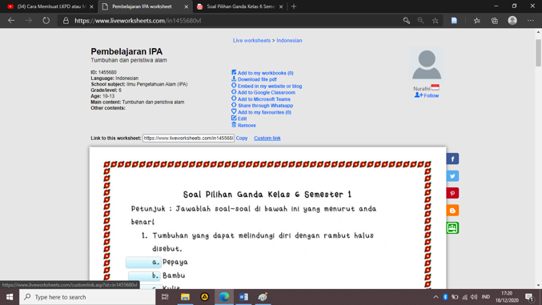

Figure 1. the custom link option on Liveworksheets

**Another information:**

In case of article in Bahasa Indonesia, the sub-chapter should be:

1. Pendahuluan
2. Metode
3. Hasil dan Pembahasan
4. Kesimpulan
5. Ucapan Terima Kasih
6. Kontribusi Penulis
7. Konflik Kepentingan
8. Pendanaan
9. Referensi