Instructions:
Carefully read this pre-review article template before you write an article for Mechanical Engineering for Society and Industry. Pre-review article templates consist of a Title page and full-text article. Article should be written by Palatino Linotype with font 11 and spaces 1.5.

Table of content
1. Introduction 2
2. Material and Method 2
3. Results and Discussion (Main Section, Body text) 2
4. Conclusion 3
5. Acknowledgement 3
6. References 3
Presenting Figures and Tables 4
Equation 5
Unit 5
Additional Information 5

After you read and understand this template, delete this first page!.

Write Title Here: Title Must Be Simple, Informative, and Reflect Important Findings of the Article
No | Full name | email | Orcid (if any)

1

2

3

…
Email: correspondingauthor@blablabla.con

¹Name of Department, University, Postal Code, Country
²Name of Department, University, Postal Code, Country
³Name of Department, University, Postal Code, Country

Highlights:
- Xxxxxxxx
- Xxxxxxxx
- xxxxxxxx

Graphical Abstract:

Abstract
The abstract must be short, interesting, simple, and easy to understand without reading the entire article. Therefore, avoid jargon, abbreviations and references. In writing abstracts, the author must be accurate, use the right words, and convey the meaning of the study. A good abstract contains the problem statement and purpose, how the research is carried out (the method), the results, and concludes with a brief statement of conclusions. In the abstract keywords are also always included. Keywords are used to index an article and are the label of an article.
Keywords: Write 3-5 keywords separated by semicolon

Introduction
The introduction of a review article is more concise than the original research paper. The introduction consists of three main paragraphs, which contain:
a. Background: contains general topics, issues or areas of concern to describe the context.
b. Issues examined: contain trends, new perspectives, gaps, or conflicts between findings.
c. Motivation/justification: contains the author's reasons for reviewing the literature.
Each of the main paragraphs can be developed according to the breadth of the topic.

Material and Method
The material and method sections contain information about data sources, data search strategies, selection criteria for articles included in the review, the number of studies included, and the methods or statistics for the analysis. The authorr must ensure that the data source is clearly identified and valid.

Results and Discussion (Main Section, Body text)
The main structure of a review article needs to be a coherent arrangement of topics. The main part is generally divided into sub-sections, for example methodological approaches, models or theories, studies that are in accordance with other research versus those that are not appropriate, chronological order, to the geographical location of the research being reviewed.
Each paragraph consists of one idea, one aspect, or one topic. In the review article, one paragraph refers to several studies so that there are more citations per paragraph. Each paragraph links the findings of the studies discussed with the research questions listed in the introduction. This link creates the coherence thread of the article being created. By linking studies with each other, a comparison of findings will be obtained as material to create a discussion or discussion. This body text section generally consists of 70-90% of the entire article, not including identity and references. As an important note, the author must ensure that article reviews are written based on ideas, not based on literature.

Conclusion
The conclusions in the review article contain the implications of the findings, interpretations by the authors, and identification of research questions that have not been resolved.

Author's declaration
Authors’ contributions and responsibilities
Write the contribution of each author here, or mark the following column.

The authors made substantial contributions to the conception and design of the study.
The authors took responsibility for data analysis, interpretation and discussion of results.
The authors read and approved the final manuscript.

Funding
Write down the research funding, if any.

Availability of data and materials
√ | All data are available from the authors.

Competing interests
√ | The authors declare no competing interest.

Additional information
Write additional information related to this research, if any.

Acknowledgement
The acknowledgment section contains thanks to the people or institutions who helped with the search and supply of literature and data, structuring the material, or the writing process.

References
Usually, there are more errors in references than other parts of the manuscript. However, with reference management software, it is now easier to avoid this problem. In the text, the author must quote all references referred to and vice versa. Minimize the use of personal communication, do not include unpublished observations, manuscripts that have not been received for publication, publications that are not reviewed by reviewers, or gray literature. Prioritize articles in English and articles from reputable journals.
To make accountable references, the author can use reference management software, such as EndNote or Mendeley. Make a list of references and citations in text that fit the IEEE style. Example of writing references in IEEE style:
[1] L. Augusto Horta Nogueira and R. Silva Capaz, “Biofuels in Brazil: Evolution, achievements and perspectives on food security,” Global Food Security, vol. 2, no. 2, pp. 117–125, 2013.
[2] A. Pradhan and C. Mbohwa, “Development of biofuels in South Africa: Challenges and opportunities,” Renewable and Sustainable Energy Reviews, vol. 39, no. 2014, pp. 1089–1100, 2014.
[3] M. Messagie, K. Lebeau, T. Coosemans, C. Macharis, and J. Van Mierlo, “Environmental and financial evaluation of passenger vehicle technologies in Belgium,” Sustainability, vol. 5, no. 12, pp. 5020–5033, 2013.

Presenting Figures and Tables
Before writing the manuscript, the first step that must be taken is to prepare Figures and Tables that are processed from the results of the study (if any). Keep in mind that a Figure and Table are worth a thousand words. Therefore, figures and tables are the most efficient way to present the results of research. Figures and tables must be presented with high quality / sharpness. The use of graphics / curve fitting software and its analysis such as Origin Graphing and Analysis (can be obtained at http://www.originlab.com/) is highly recommended for making graphics that can be displayed with good quality and clear.
Generally, tables provide actual experimental results, while figures are often used for comparison of experimental results with previous work, or with calculation / theoretical values.
- When presenting figures and tables, several things need to be considered:
- Avoid graphic plots that are too crowded.
- Use the appropriate axis.
- Symbols and data sets must be clear, easily distinguishable.
- If the table contains very much data, put the table as an attachment, not as body text.
All images should be made in high quality JPEG format, at least 300 dpi with sharp color settings. A good illustration to present the results of the study is presented in Figure 1.
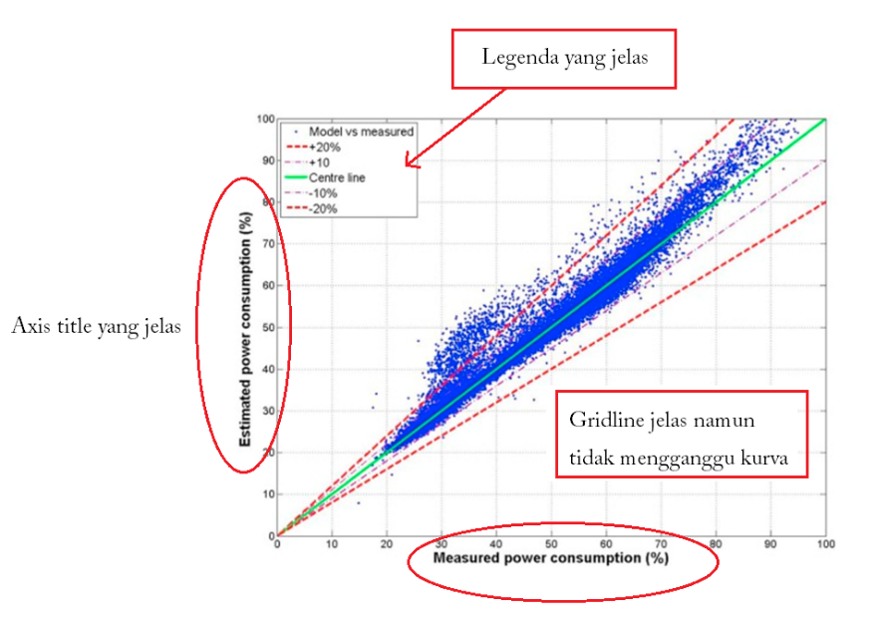
Figure 1. Example of a research result shown in the figure [4].

A good figure, always equipped with a legend and without giving the title of the image at the top. The coordinate axis is clearly visible with a scale that can be read easily. The colors on the grid line are made dimmer than the plot. Then, an example showing a table of good research results is presented in Table 1 as follows.
Table 1. Example shows research data in Table [5]
Materials | Variables | Temperature (°C)
 |  | 250 | 300 | 350
Scrap tyre | Stove temperature (°C) | 401 | 492 | 525
 | Water temperature (°C) | 25 | 25 | 25
 | Condenser temperature (°C) | 26 | 26 | 26
 | Oultet condenser temperature (°C) | 26 | 27 | 27
 | Outlet Reactor (°C) | 29 | 36 | 53
 | Liquid volume (ml) | 160 | 175 | 190
 | Liquid temperature (°C ) | 25 | 26 | 25
Scrap tyre and catalyst | Stove temperature (°C) | 398 | 490 | 528
 | Water temperature (°C) | 25 | 25 | 25
 | Condenser temperature (°C) | 26 | 26 | 26
 | Oultet condenser temperature (°C) | 25 | 27 | 38
 | Outlet Reactor (°C) | 29 | 30 | 50
 | Liquid volume (ml) | 150 | 160 | 165
 | Liquid temperature (°C ) | 28 | 30 | 30

Equation
The mathematical equation must use the "Equation Editor" and be given the serial number in (1) (2), (3) and so on.

Unit
The unit must use the International Unit.

Additional Information
- All figures, tables and equations must be mentioned in the paragraph before the figures, tables and equations are displayed. Avoid the words "Next figure, Table above, Equation below", replace it with the clear statement of Figure 1, Table 3, Equation (4), and so on.
- Use Indonesian or English properly and correctly.

